Computer Networks (CS303)

Assignment - 3

**U19CS012**

Getting Familiar with Cisco Packet Tracer

A.) Installation Steps

1. Sign Up [<https://id.cisco.com/signin/register>]

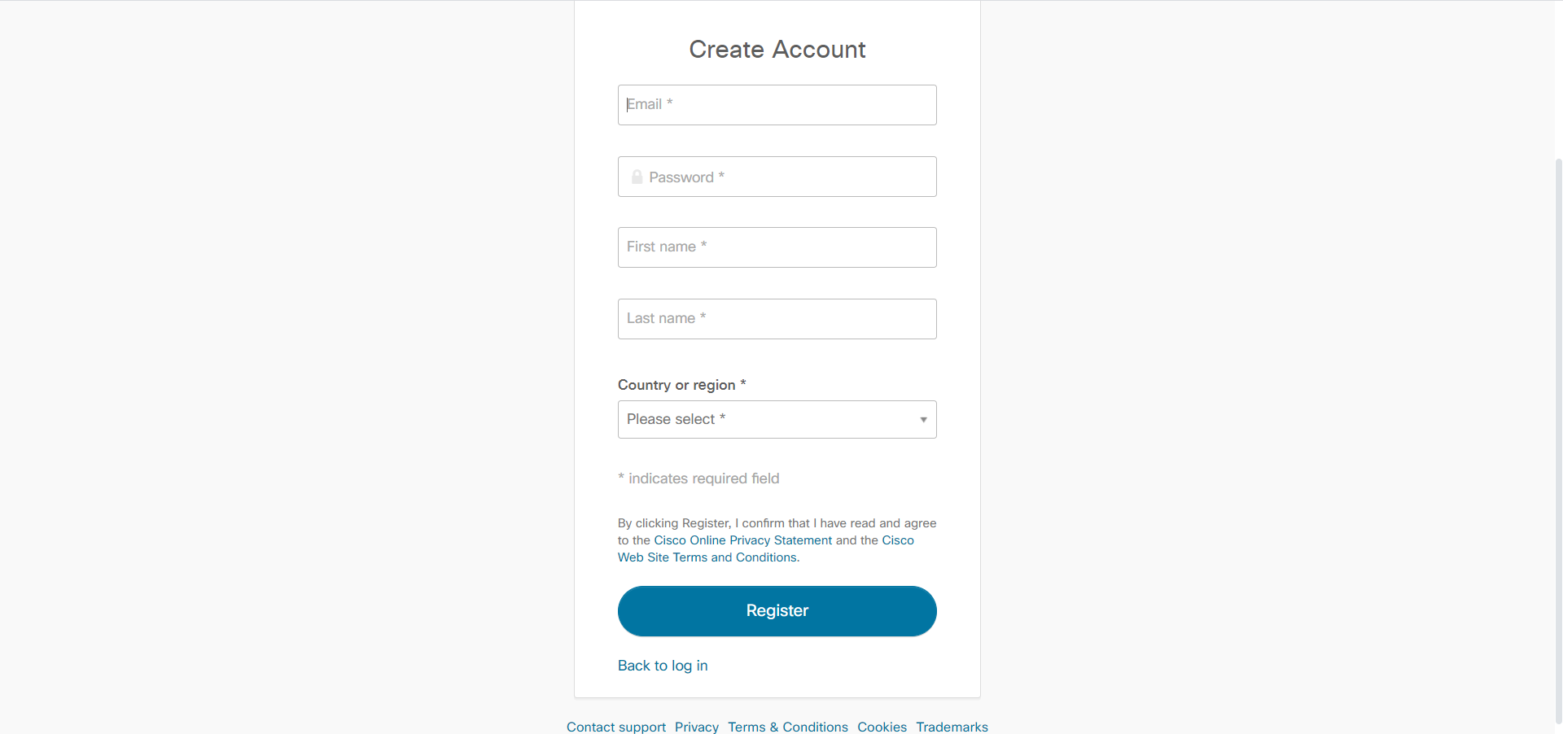

1. Account Activation on Email

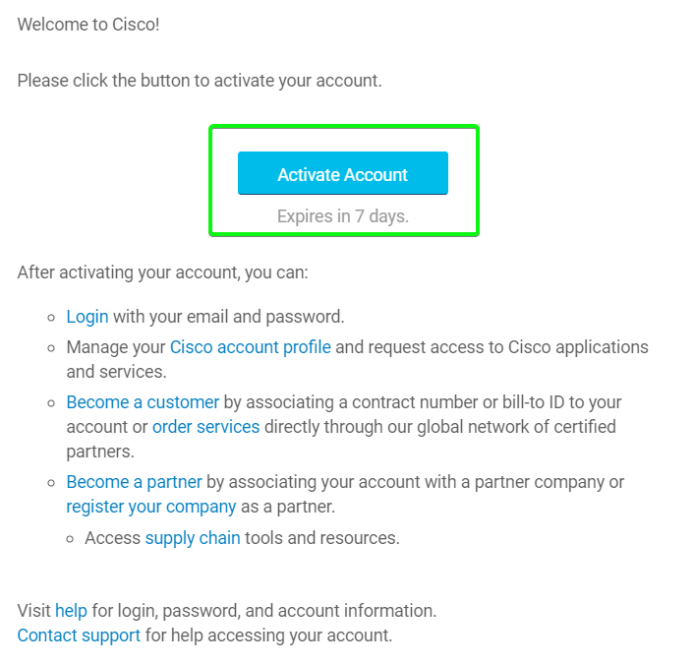

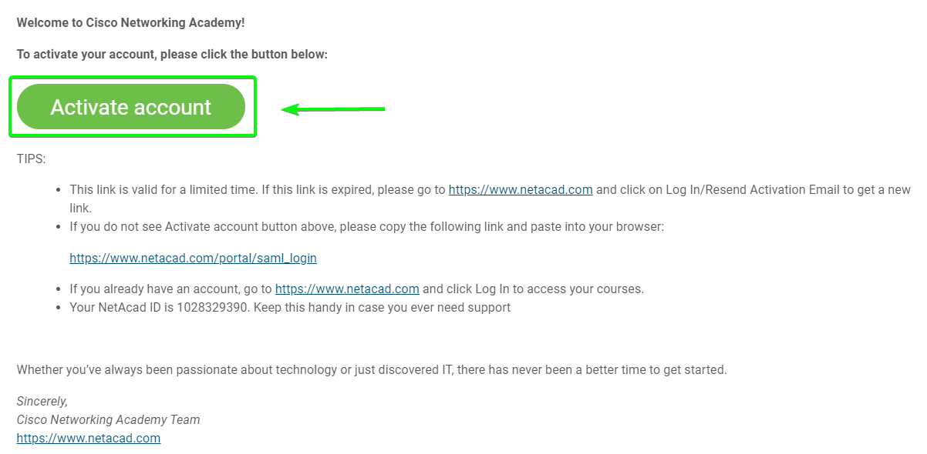

1. Enroll in this Course [<https://www.netacad.com/courses/packet-tracer/introduction-packet-tracer>]

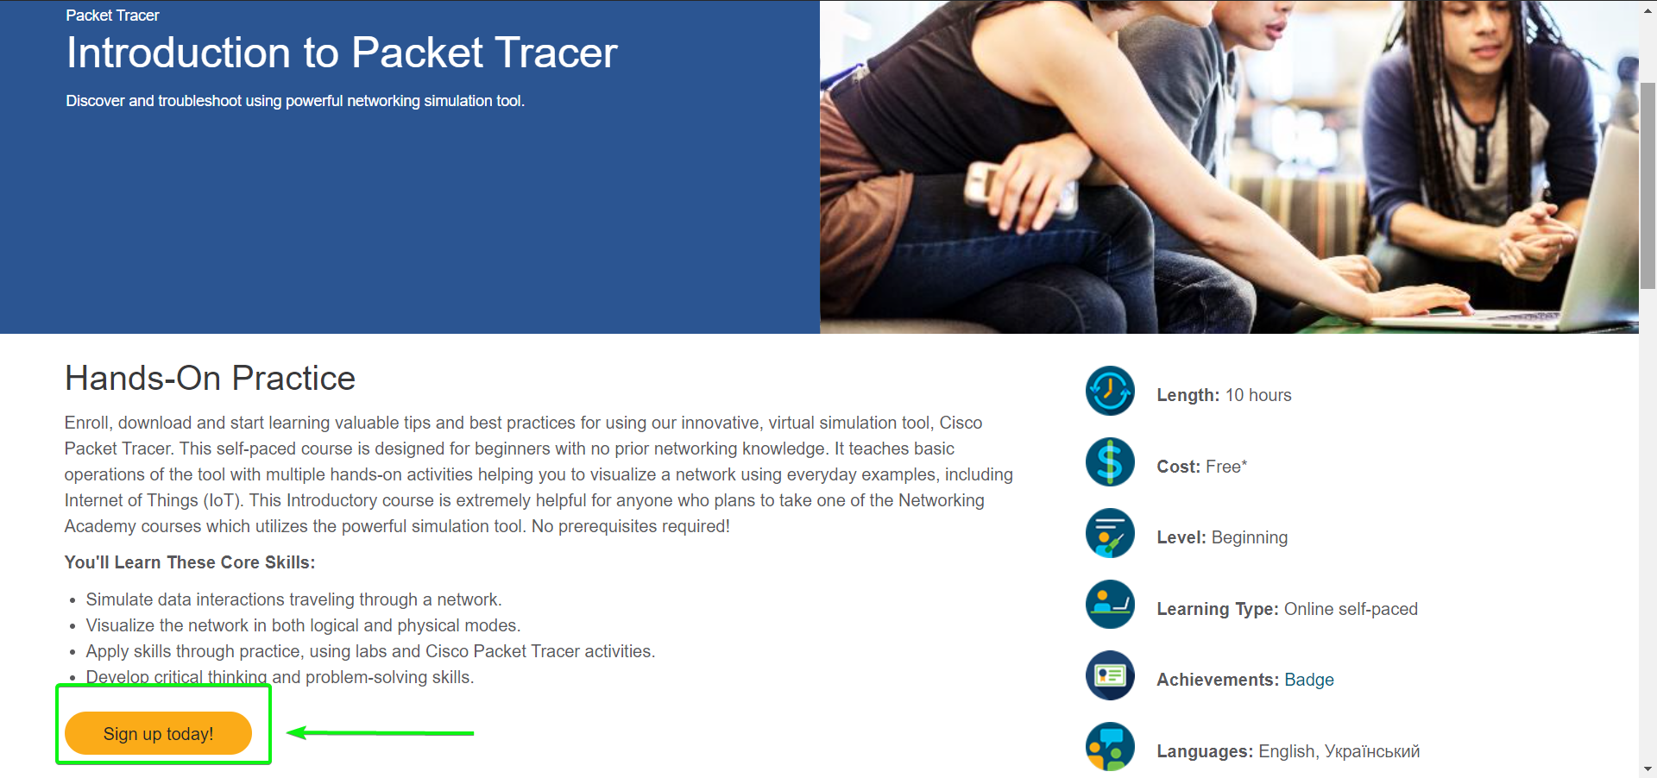

1. Go to this Course "**Introduction to Packet Tracer English 0821a**" & Click on "Student Support and Resources Page"

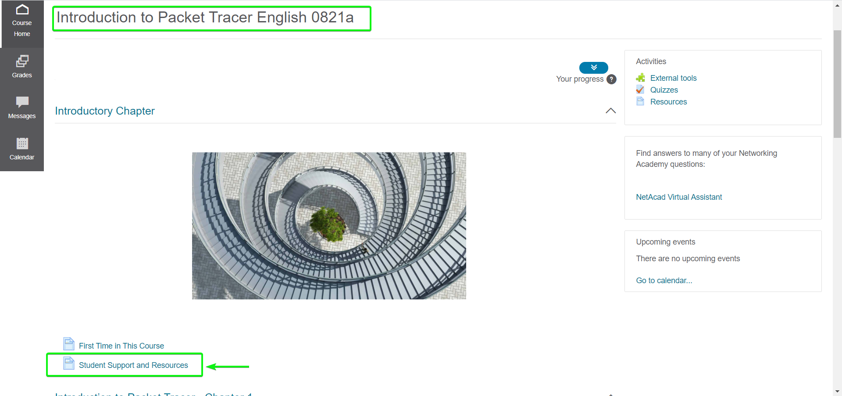

1. Third Row ["Packet Tracer"] in Table will have the Installation Link of the Software

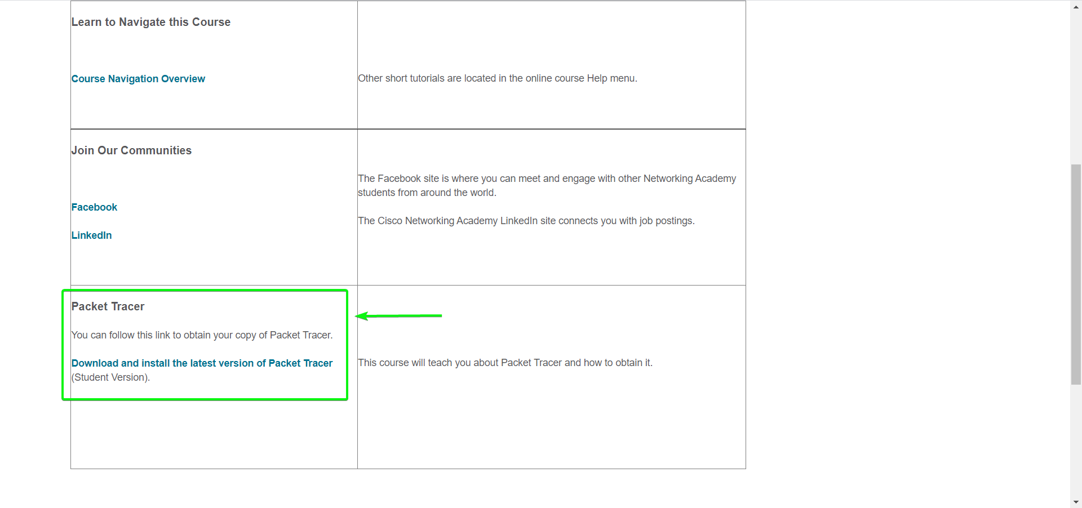

1. Wait Patiently for it to Download [200 MB File]

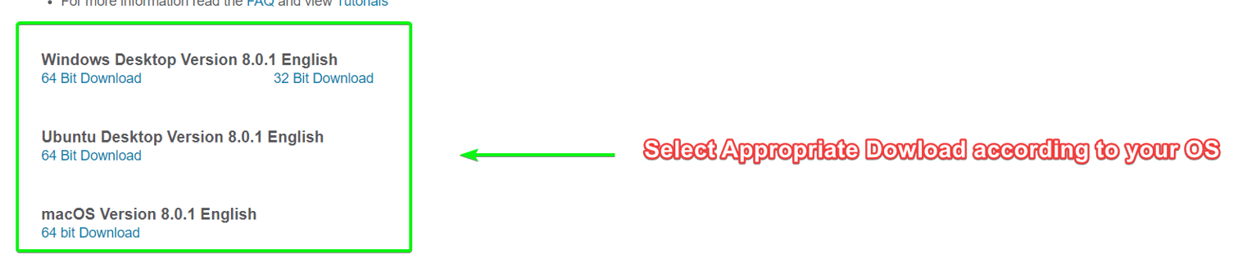

B.) Understanding the Interface

Packet Tracer is a tool that allows you to simulate real networks.

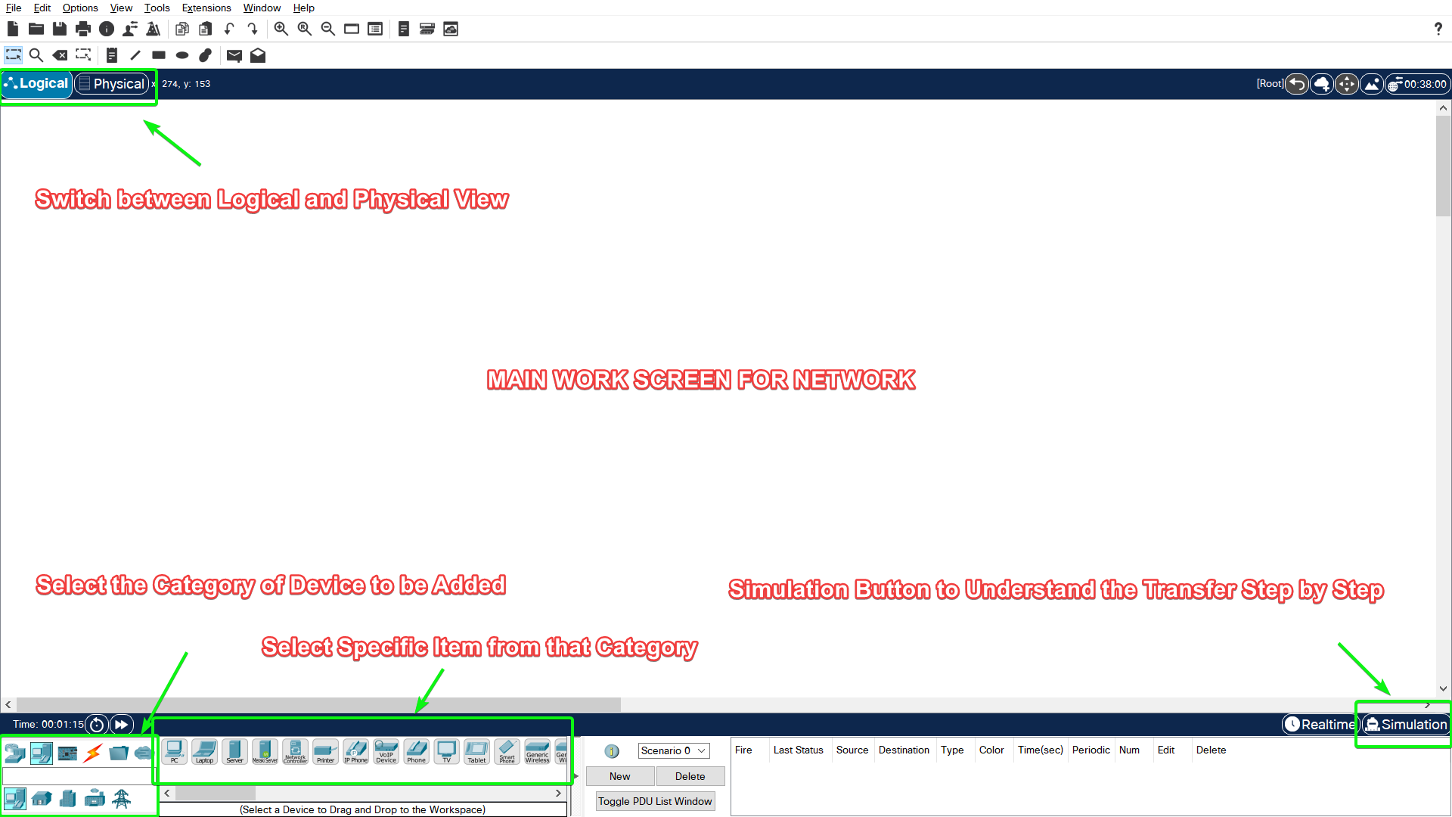

C.) Create Simple Network of 2 Computers

Step 1

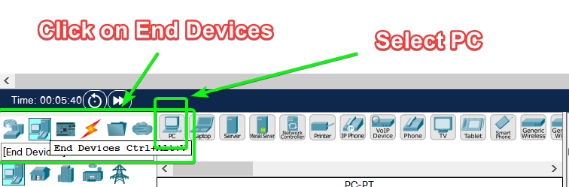

Step 2

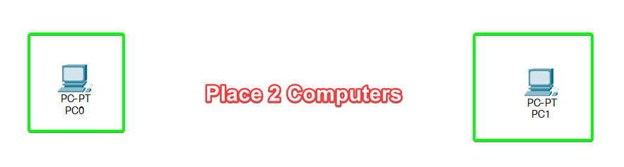

Step 3: IP Configuration

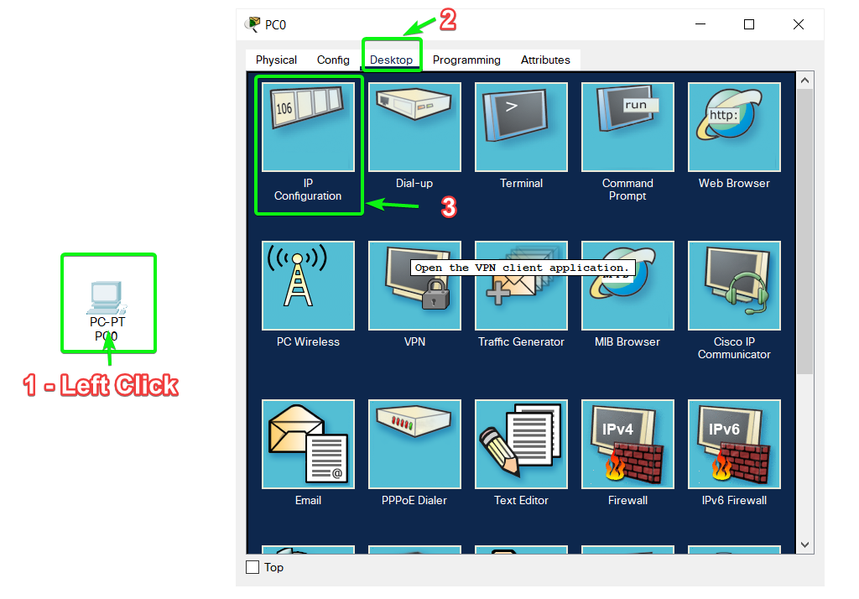

Step 4: Set IPv4 Address

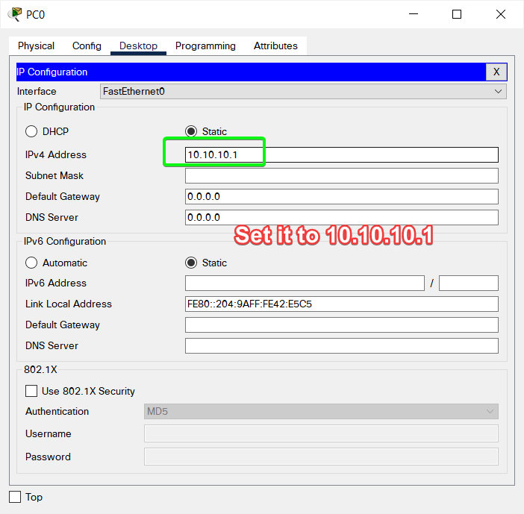

[Do Similar Step of Setting IPv4 Address for Other Devices as well]

Step 5: Select Connecting Wire

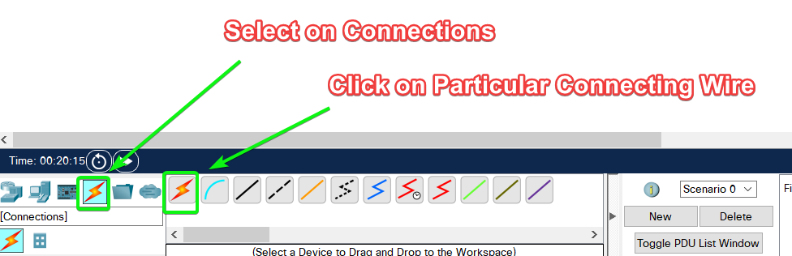

Step 6: Establish Connection

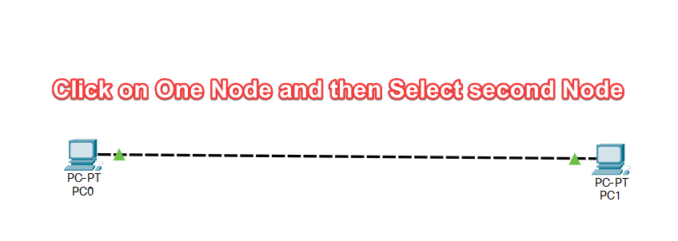

Step 7: Hover Over and Check if Link is **Up**

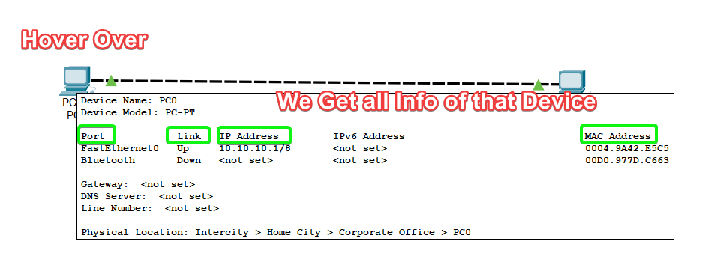

Step 8: Ping the Other Computer

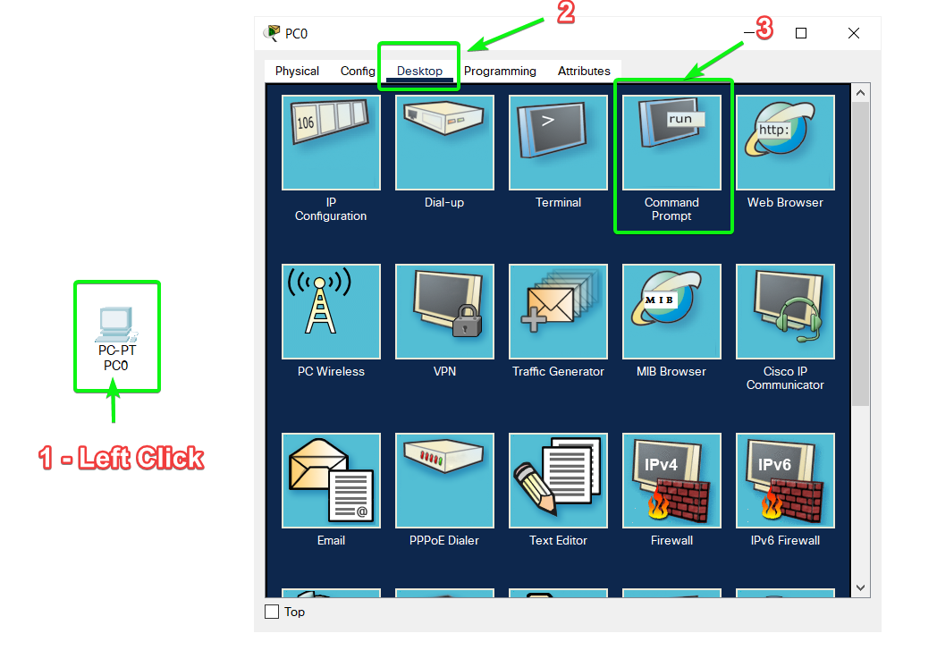

Step 9: Write Command

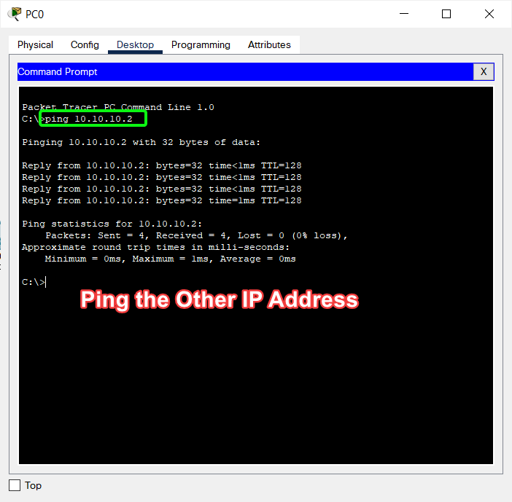

Step 10: You can also see the Step By Step Transfer Using the **Simulation** Button

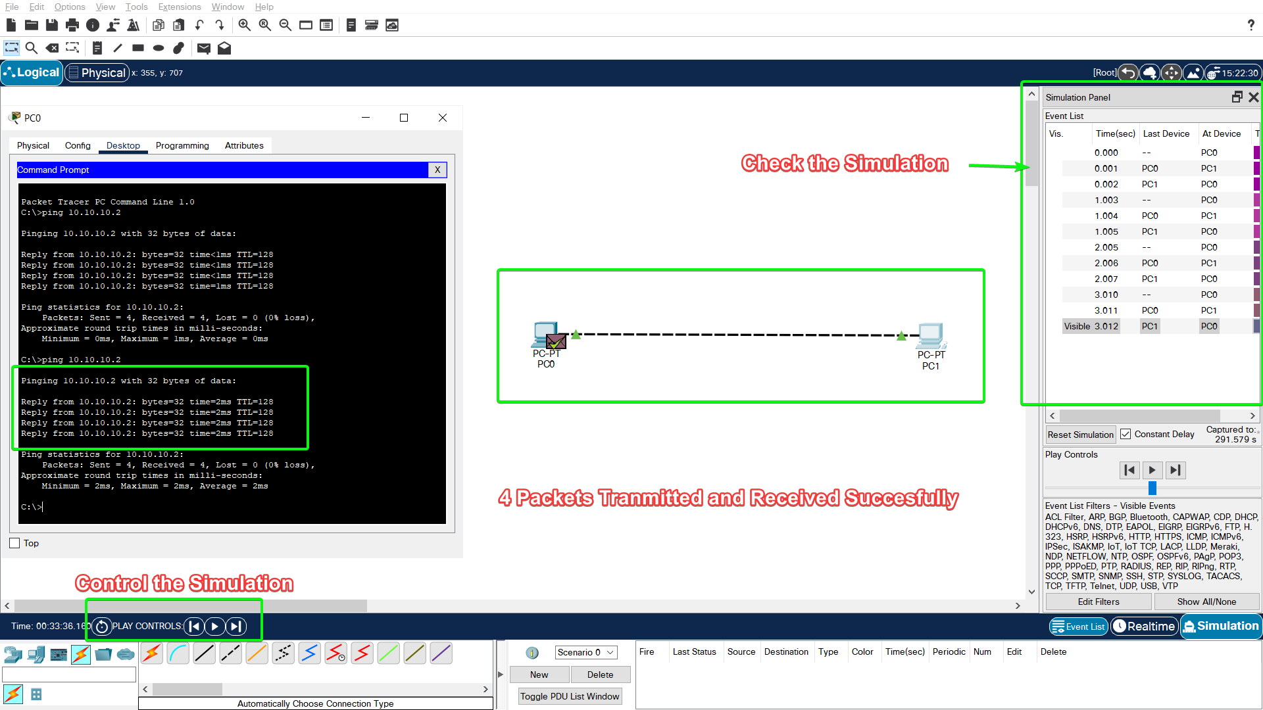

D.) Create Simple Network of 3 Computers & Switch

Step 1: Draw the Below Shown Network

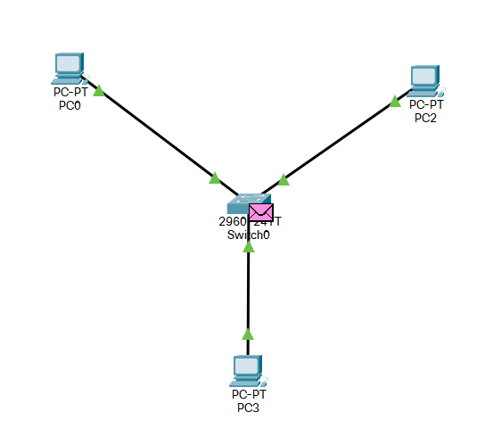

Step 2: Send Ping Request to another Node [Simulation]

Packet ready to be sent

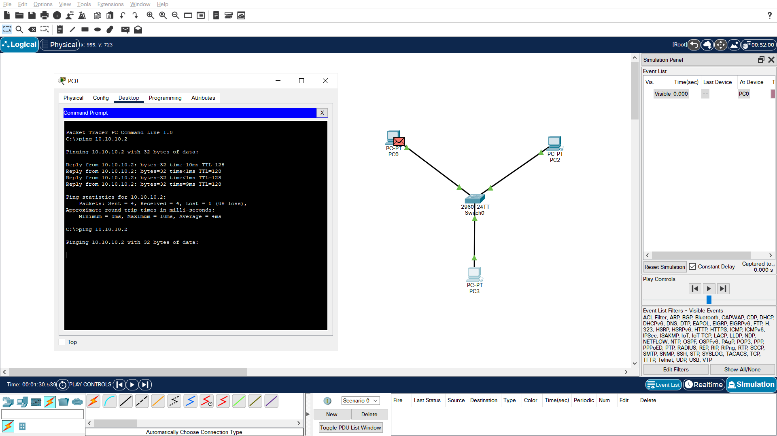

Packet Sent via Router

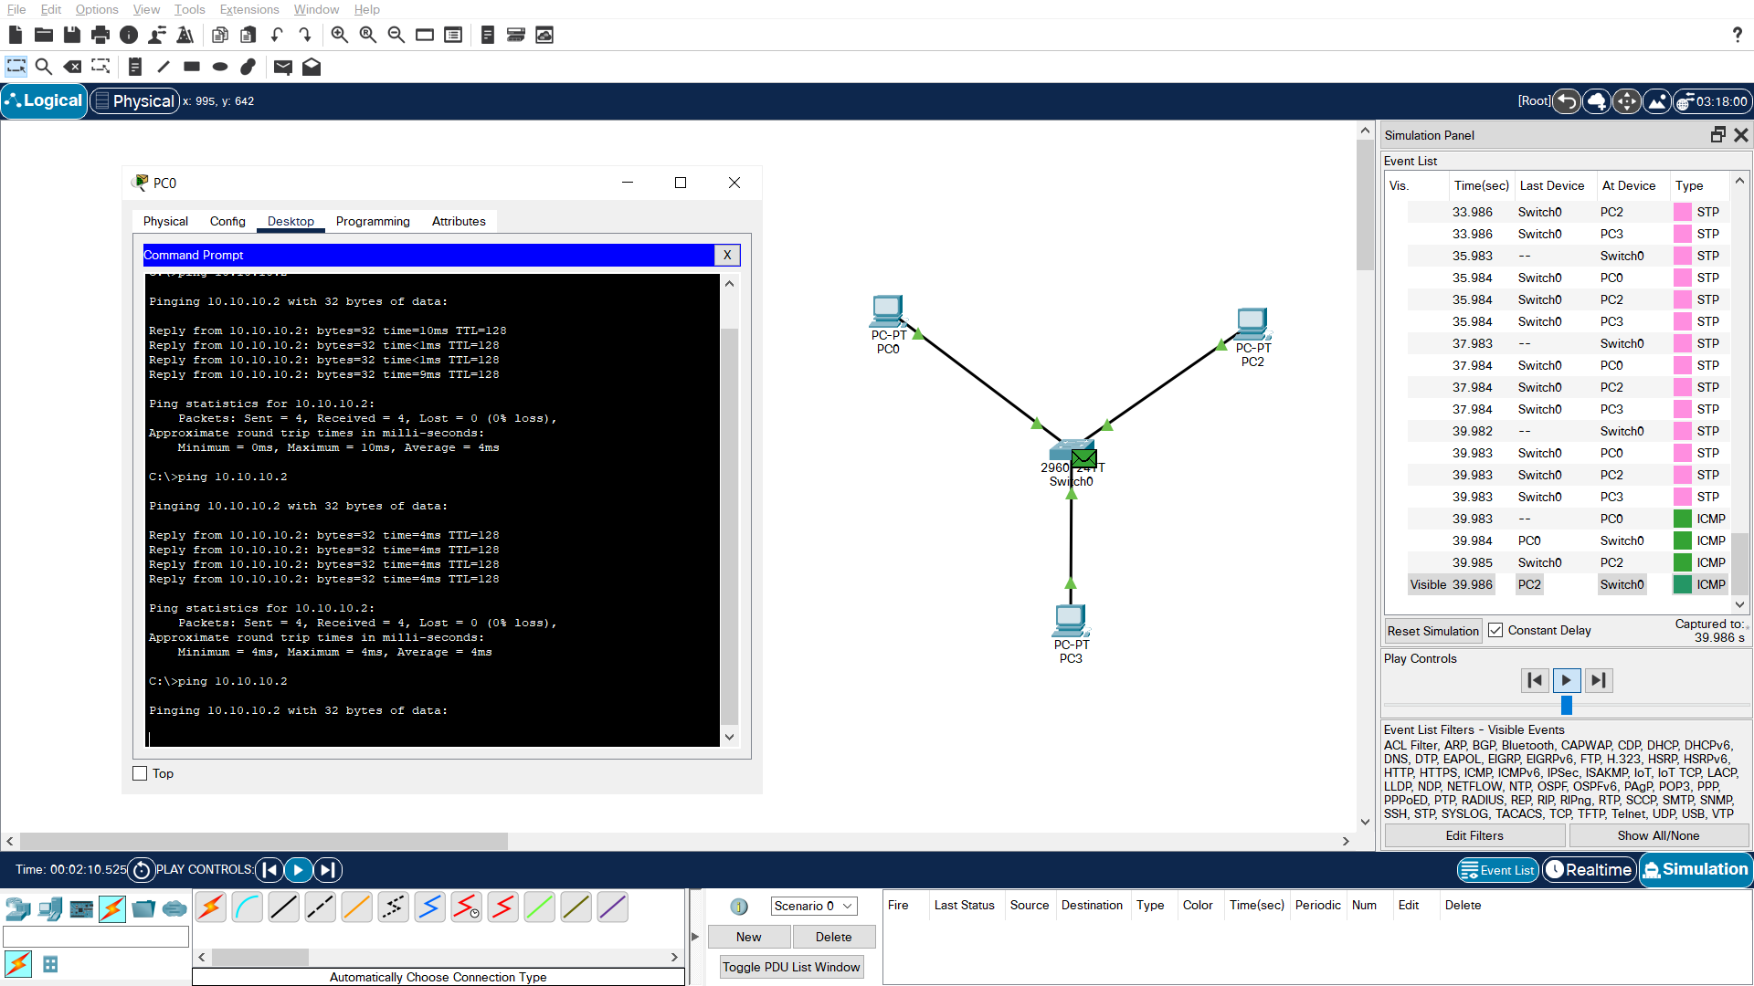

Packet Received to another Node

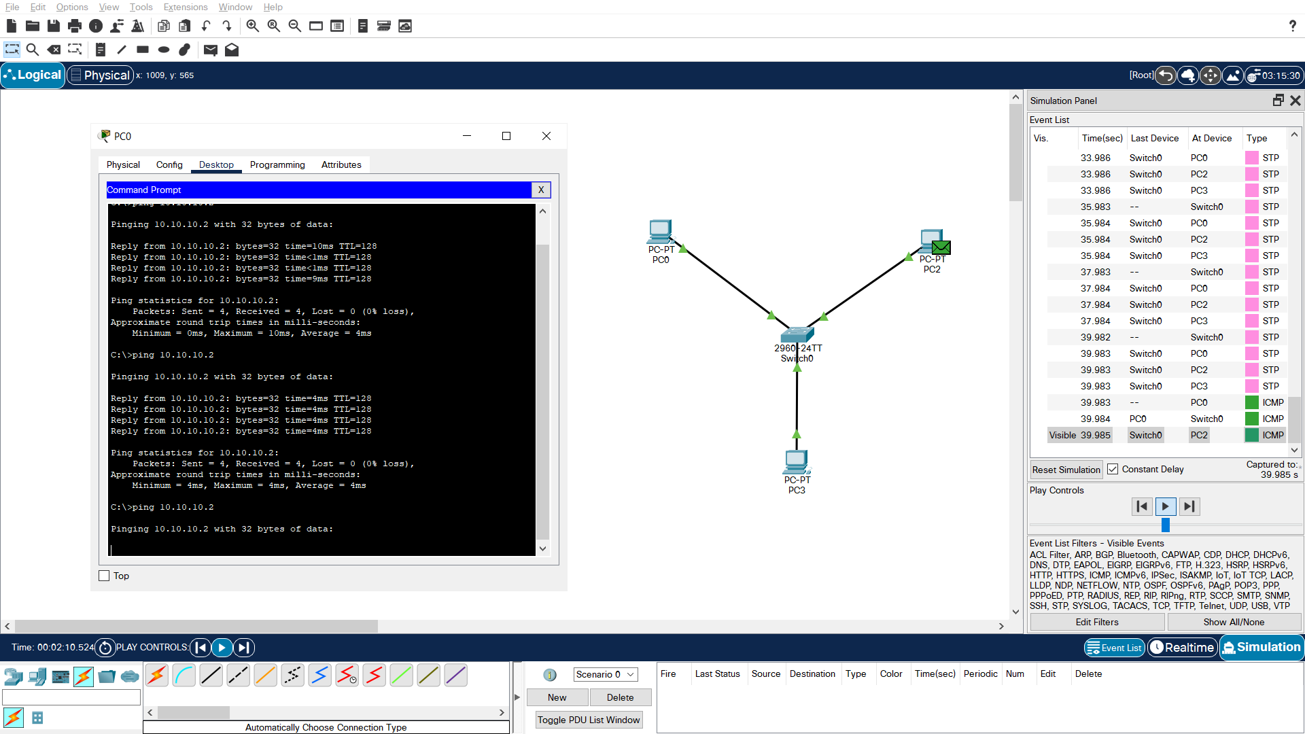

Packet Send from another Node to Switch



Packet Received Successfully

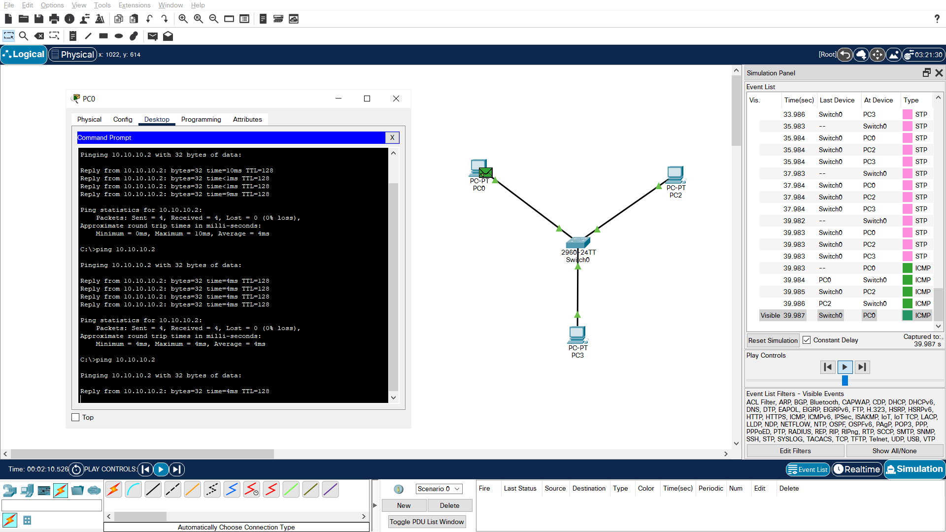

[Process Repeats for Remaining 3 Packets]

Step 3: All 4 Packets Transferred and Received Successfully!

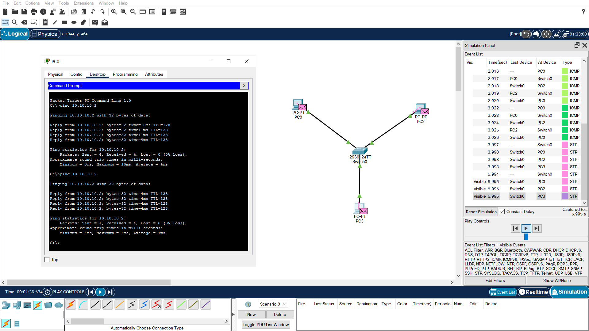

In this Practical Class, we Installed Cisco Packet Tracer and Got Familiar with its Interface.

We also Built Two Simple Networks and Tested it’s Functionality using Simulator.

SUBMITTED BY:

**U19CS012**

BHAGYA VINOD RANA